Name: __________________________________
Design and Drawing for Production - Architecture Design
At-Home activity

DESIGN A HOME

Problem: A client has asked you to design a new home. They have listed directions and requirements that need to be followed. You are to design and draw the home and then re-create it on the computer using web-based software.

Client Guidelines that must be followed:
- Ranch style home or a one-story apartment/townhouse
– if an apartment/townhouse is chosen, draw the single unit, not the entire apartment building.
- Design must include the following:
  - 2 car garage e. Kitchen
  - 3 bedrooms with closets f. Laundry room
  - Living room g. Entry area with a closet
  - Dining room h. Bathroom – you should have (1) full and (1) ½ bathroom
Full = Toilet, sink vanity, shower/tub ½ = sink vanity and toilet
- Keep your house within a one -story floor plan
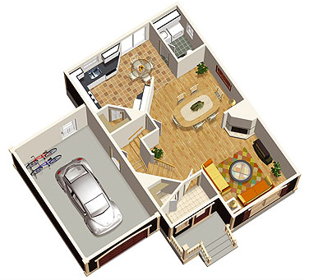

Requirements that need to be completed in order
- Draw 1 rough sketch Bubble Diagram of your home idea – Watch video tutorial on how to draw this type of plan in Schoology

- Draw 1 refinement drawing on paper
  - Use a ruler or straight edge for neater lines
  - Label all rooms and features of the home

A sample of what you will be doing
- Use FloorPlanner.com web-based computer software to create your home in 3D
  - Watch tutorials on how to use the software – links in Schoology
  - Build the home with all rooms
  - Add furniture to the rooms
  - Create wall colors, flooring to make your design unique and special

